**OMIS 673 MODULE 4 HOMEWORK**

**Visual 1** (20 points):

1. In your “OMIS 673 Class Data” file, find two tables, “Clinic Patients Demographics (copy)” dataset and “Patient Readmission Days” dataset.
2. Combine the two tables properly either using Joining or Relationships technique.
3. Then answer the following questions by creating your own visualizations. You should modify your charts so that they are clutter-free and confusion-free. The choice of chart type is up to you.

* Which race group of patients does spend the longest time on average till readmission?

Ans. The American Indians/Alaska Natives race group of patients spend time till readmission.

* In that group, which gender does spend more days (on average) before returning to the hospital?

Ans. In the American Indians/Alaska Natives ethnicity group, female gender has spent more days before returning to the hospital.

**Visual 2** (20 points):

1. Follow Video 3.2 (Interpreter) and 3.3 (Pivot and Column-Splitting) to get a new dataset, “WHO Deaths Projection per 100,000”
2. Using this new dataset, generate a chart that shows projected deaths per 100,000 across different age groups.
3. Modify your chart so that it is clutter-free and confusion-free.
4. Which age group has the lowest projected deaths rate?

Ans. The age between 5-14 group has the lowest death rate.

**Visual 3** (10 points): Review Video 3.4 (Calculated Fields with a Deviation Chart). Now, you create another variable, *FTE off Percentage*, which is defined by 100* (actual FTE-budgeted FTE)/actual FTE. This tells you by how many percentage points your budgeted FTE value is off. Show this new variable’s values by the department. Show the data labels.

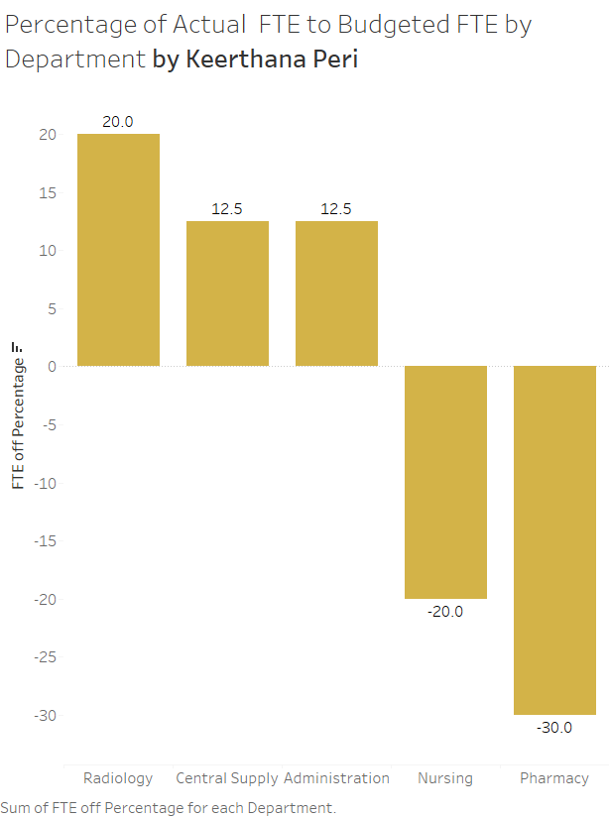

**Visual 4** (10 points): Create your own chart, “Department FTE-Percent of Total by Your Name”, covered in Video 3.5(Table Calculations).

